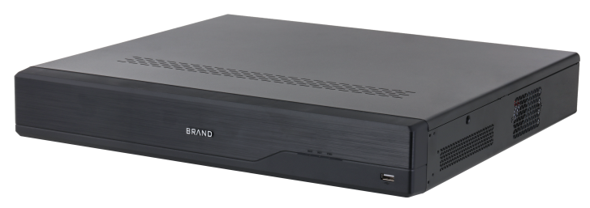
LXN9432D-P24
32CH 4 HDD Pro AI NVR with 24CH PoE

Key Features

- Smart Encoding/H.265/H.264 video Compression
- Up to 32 MP Resolution Recording
- 24 Independent PoE Network Interfaces, 1-8 Ports support S-PoE, up to 800m PoE transmission
- 2x Independent HDMI Ports(4K, 3840 × 2160) and VGA Ports
- Camera AI Compatibility: Face Detection, VCA, MD2.0 , License Plate Recognition, People Counting, Heat Map, Object Monitoring
- Recorder AI Feature: Face Recognition, VCA, MD2.0, X- Search Technology
- Supports remote configuration and management of IPC, such as setting parameters, getting information, batch upgrading
- Support X-Search
LXN9432D-P24
Specification
Video/Audio
IP Video Input | 32-ch
Recording Resolution | 32MP, 16MP; 12MP; 8MP; 6MP; 5MP; 4MP; 3MP; 1080p; 720p; D1; VGA; CIF
HDMI Output Resolution | 4K (3840 × 2160), 1920 × 1080, 1280 x 1024, 1280 x 720,
VGA Output Resolution | 1920 × 1080, 1280 x 1024, 1280 x 720
Video Output Mode | HDMI1/HDMI2 independent output, HDMI1/VGA1 simultaneous output, HDMI2/VGA2 simultaneous output
Two-way Audio Input | 1-ch, RCA
Audio Output | 1-ch, RCA
Third-party Camera Access | ONVIF; RTSP
Decoding
Decoding Format | Smart Encoding; H.265; H.264; H.264H; H.264B; MJPEG
Live View/Playback Resolution | 32MP, 16MP; 12MP; 8MP; 6MP; 5MP; 4MP; 3MP; 1080p; 720p; D1; VGA; CIF
Decoding Capability | AI ON: 1-ch@32MP(30fps)/2-ch@16 MP (30 fps)/4-ch@8 MP (30 fps)/12-ch@4 MP (30 fps)/24-ch@1080p (30 fps)  AI OFF: 2-ch@32MP(30fps)/4-ch@16 MP (30 fps)/8-ch@8 MP (30 fps)/16-ch@4 MP (30 fps)/32-ch@1080p (30 fps)
Synchronous Playback | 1, 4, 9, 16, 25, 36 views
Intelligent
Intelligent Motion Detection | 16-ch, IMD by Camera  8-ch, IMD by NVR
Perimeter Protection | 16-ch, Line Crossing by Camera  4-ch, Line Crossing by NVR
Face Recognition | 2-ch, human face capture and recognition  16-ch, face picture comparison alarm, (Face picture captured From Camera)
Face Picture Database | Up to 20 face picture libraries, with up to 20,000 face pictures in total
Network
Incoming Bandwidth | 384 Mbps (200 Mbps with AI enabled)
Outgoing Bandwidth | 384 Mbps (200 Mbps with AI enabled)
Network Protocol | HTTP; HTTPS; TCP/IP; IPv4/IPv6; UPnP; SNMP; RTSP; UDP; SMTP; NTP; DHCP; DNS; DDNS
Network Interface | 1, RJ-45 10/100/1000 Mbps self-adaptive Ethernet Interface
PoE Interface | 24, RJ-45 10/100 Mbps self-adaptive Ethernet interface, 1-8 Ports support S-PoE
PoE Standard | IEEE 802.3 af/at
Mobile Phone Access | Pro-X
Auxiliary Interface
SATA | 4 SATA interface
Capability | Up to 16 TB for each hard disk
Alarm In/Out | 16/6
USB Interface | Front panel: 1 × USB 2.0; Rear panel: 2 × USB 3.0
General
Power Supply | 100 to 240 VAC, 50 to 60 Hz
Power Consumption | < 13 W (HDD not included,)  Total output power of PoE is 250W, the maximum output power of a single port is 25.5W
Working Temperature | –10 °C to +55 °C (+14 °F to +131 °F)
Working Humidity | 10℅ to 93℅
Product Dimensions | 442.0 mm × 413.8 mm × 68.0 mm (17.40" × 16.29" × 2.68") (W × D × H)
Weight | 4.65kg(10.24 lb), without HDD
Certifications | FCC: Part 15 Subpart B

Dimensions (mm[inch])
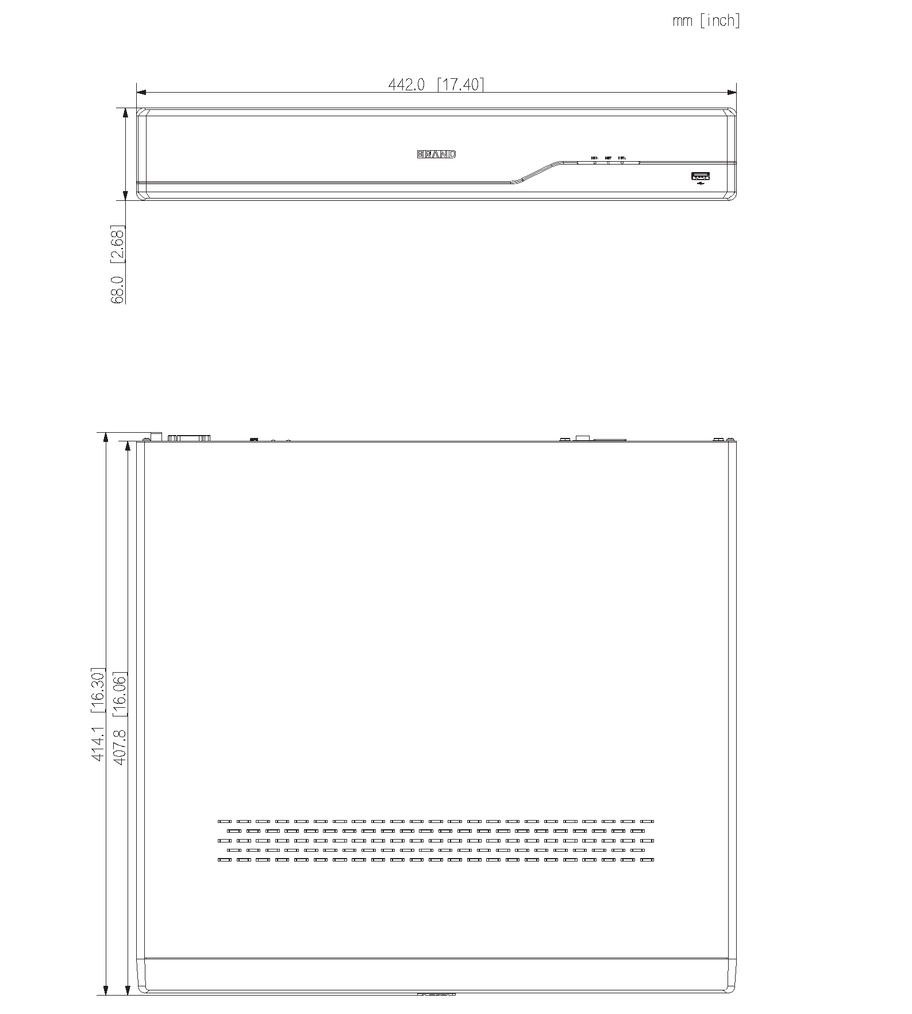

Physical Interface

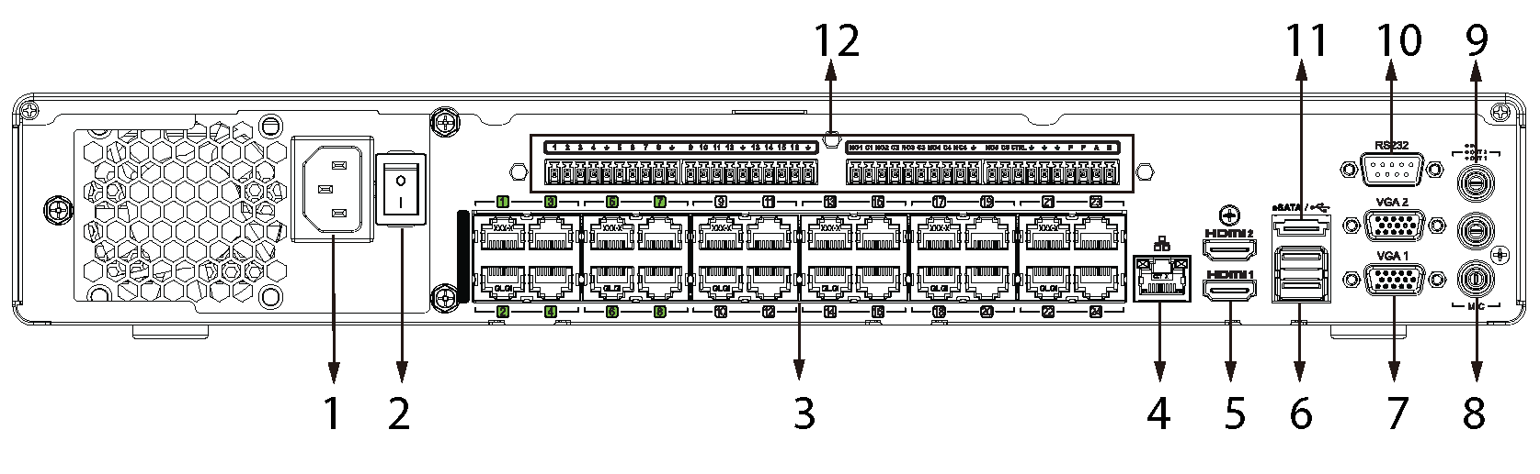

No. | Description | No. | Description
1 | Power Supply | 7 | VGA Ports
2 | Power Switch | 8 | Audio OUT, RCA Connector
3 | PoE Ports | 9 | Audio IN, RCA Connector
4 | LAN Network Port | 10 | RS232 Network Port
5 | HDMI Ports | 11 | eSATA Port
6 | USB Ports | 12 | Alarm In/Out

